**Refrigerant**

**Leak Testing**

**PROCEDURES**

**and RECORD BOOK**

**Vessel Name:**

**In accordance with:**

**-Regulation (EC) No.517/2014 (F-Gas Regulation)**

**-Regulation (EC) No.1005/2009 (Regulation on Ozone Depleting Substances)**

**-EN 378-4 Para. 4.3 Operation/Maintenance**

**-EN 378-2 (08/2012) Art. 6.4.3.5**

**-Regulation (EC) 303/2008 (requirements)**

**-Regulation (EC) 1516/2007 (leakage check)**

**INDEX**

**Section 1 ……………….. Procedures**

**Section 2 ………………… Refrigerant System Data and Circuits**

**Section 3 ………….……… Refrigerant Circuit(s) Leak Test**

**Section 4 ………….……… Maintenance and Repair**

**Section 5 ………….……… Processing and Disposal of Refrigerant / Oil**

|  |
| --- |
| **SECTION 1 Procedures** |

The Refrigeration procedures and requirements listed herewith:

* **Apply to** all **permanently installed refrigeration and air conditioning installations** on board with **more than 3 kg** of refrigerant.
* **Do not apply to** stand-alone refrigerators, freezers and ice makers used in galleys, pantries, bars and crew accommodation

Where hydrofluorocarbon (HFC) refrigerants are used, they are to have an Ozone Depleting Potential (ODP) rating of zero and a Global Warming Potential (GWP) of less than 1950, based on a 100- year time horizon (see below) typical values for common refrigerants

**GLOBAL WARMING POTENTIAL (GWP) OF REFRIGERANTS:**

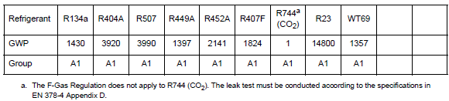

*Identify and add GWP for other refrigerant gases used onboard as necessary:*

|  |  |  |  |  |  |  |  |
| --- | --- | --- | --- | --- | --- | --- | --- |
| Refrigerant |  |  |  |  |  |  |  |
| GWP |  |  |  |  |  |  |  |

Maintenance, servicing or repair work of shall be undertaken without releasing the refrigerant charge into the atmosphere. This shall be done by the compressor(s) evacuating a system charge into a liquid receiver and/or by recovery units evacuating into dedicated cylinders. Unavoidable minimal releases are acceptable when using recovery units. Different refrigerant types shall not be mixed during evacuation / recovery.

Leakage of refrigerants shall be minimized by leak prevention and periodic leak testing by qualified personnel holding relevant certification

Leak testing frequency and the maximum allowable annual leakage rate shall be followed as below and records shall be maintained as per this record book:

|  |  |  |
| --- | --- | --- |
| **Charge size kg** | **Min. frequency of test months** | **Max allowable annual leakage %** |
| 3 – 30 | 3 | 10% |
| 30-300 | 1 | 5% |
| >300 | 1 | <3% |

**LIST OF COMMON REFRIGERANTS:**

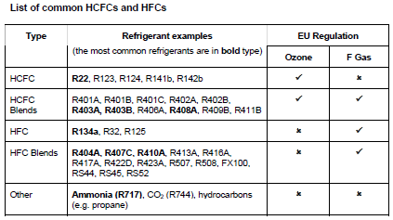

*\*For HCFC (Ozone Depleting Substances) – see also ODS record book SAF53(A)*

**LEAK TESTING FREQUENCY REQUIREMENTS:**

Fluorinated Gas (F Gas) Regulation:

• Systems containing between 3 and 30 kg of HFCs must be leak tested annually;

• Systems containing more than 30 kg of HFC must be leak tested twice a year

• Systems containing over 300 kg of HFC must have permanent fixed leak detection.

If a leak is found it must be fixed and the system re-tested at the point of repair within

one month.

Ozone Depleting Substance (ODS) Regulation:

• Systems containing over 3 kg of HCFC must be leak tested annually.

**MOST EFFECTIVE LEAK TESTING METHODS:**

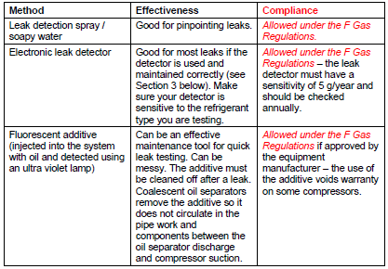

**PERMISSIBLE SPECIFIC REFRIGERANT LOSS ANNUALLY:**

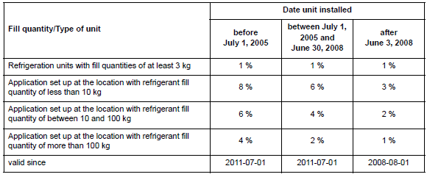

|  |
| --- |
| **SECTION 2 GWP Refrigerant System Data and Circuits** |
| *Add more pages to Section 2 if necessary in order to list all GWP Refrigerant equipment*  **SYSTEM DATA**   |  |  |  |  | | --- | --- | --- | --- | | Type |  | | | | Unit |  | | | | Year of production |  | | | | Startup |  | | | | Refrigerant circuits | 1 | 2 | 3 | | Available Yes/No |  |  |  | | Refrigerant type |  |  |  | | Charge weight in kg |  |  |  | | Permissible specific refrigerant loss in % |  |  |  | | GWP of refrigerant |  |  |  | | CO2 equivalent in t=  (Fill quantity kg x GWP ) / 1000 |  |  |  | |  |  |  |  | | **Requisite test interval for systems ≥ 5 t CO2 equivalent (according to Regulation (EU) No. 517/2014) without leak detection system** | | | | | Annually 5 – 50 t CO2 equivalent |  |  |  | | Bi-annually ≥ 50 – 500 t CO2 equivalent |  |  |  | | Quarterly≥ 500 t CO2 equivalent |  |  |  | | **Requisite test interval for systems ≥ 5 t CO2 equivalent (according to Regulation (EU) No. 517/2014) with leak detection system** | | | | | Every 2 years 5 – 50 t CO2 equivalent |  |  |  | | Annually ≥ 50 – 500 t CO2 equivalent |  |  |  | | Bi-annually≥ 500 t CO2 equivalent |  |  |  | |  |  |  |  | | **Requisite test interval for systems < 5 t CO2 equivalent (according to EN 378-4)** | | | | | Annually for fill quantity ≥ 3 kg |  |  |  | | Bi-annually for fill quantity ≥ 30 kg |  |  |  | | Quarterly for fill quantity ≥ 300 kg |  |  |  | |

|  |  |  |  |  |  |  |  |  |
| --- | --- | --- | --- | --- | --- | --- | --- | --- |
| **SECTION 3 Refrigerant Circuit(s) – Leak Test** | | | | | | | | |
| *Add more pages to Section 3 if necessary in order to list all Refrigerant equipment / Circuits*  **REFRIGERANT EQUIPMENT ______ CIRCUIT_____ - LEAK TEST:** | | | | | |
| **Date of test** | **Tightness requirement** | | **Specific refrigerant loss kg per test** | **Specific refrigerant loss in % per year** | **Responsible Engineer’s Name / Signature** | |
| **Met** | **Not met** |
|  |  |  |  |  |  | |
|  |  |  |  |  |  | |
|  |  |  |  |  |  | |
|  |  |  |  |  |  | |
|  |  |  |  |  |  | |
|  |  |  |  |  |  | |
|  |  |  |  |  |  | |
|  |  |  |  |  |  | |
|  |  |  |  |  |  | |
|  |  |  |  |  |  | |
|  |  |  |  |  |  | |
|  |  |  |  |  |  | |
|  |  |  |  |  |  | |
|  |  |  |  |  |  | |
|  |  |  |  |  |  | |
|  |  |  |  |  |  | |
|  |  |  |  |  |  | |
|  |  |  |  |  |  | |
|  |  |  |  |  |  | |
|  |  |  |  |  |  | |
|  |  |  |  |  |  | |
|  |  |  |  |  |  | |
|  |  |  |  |  |  | |

|  |  |  |  |  |  |  |
| --- | --- | --- | --- | --- | --- | --- |
| **SECTION 4 Maintenance and Repair** | | | | | | |
| *Add more pages to Section 4 if necessary in order to record all Maintenance and Repair (alternatively use PMS)* | | | |
| **Date** | **System / Circuit** | **Report** | **Responsible Engineer’s Name / Signature** | |
|
|  |  |  |  | |
|  |  |  |  | |
|  |  |  |  | |
|  |  |  |  | |
|  |  |  |  | |
|  |  |  |  | |
|  |  |  |  | |
|  |  |  |  | |
|  |  |  |  | |
|  |  |  |  | |
|  |  |  |  | |
|  |  |  |  | |
|  |  |  |  | |
|  |  |  |  | |
|  |  |  |  | |
|  |  |  |  | |
|  |  |  |  | |
|  |  |  |  | |
|  |  |  |  | |
|  |  |  |  | |
|  |  |  |  | |
|  |  |  |  | |
|  |  |  |  | |

|  |  |  |  |  |  |  |  |  |  |  |
| --- | --- | --- | --- | --- | --- | --- | --- | --- | --- | --- |
| **SECTION 5 Processing and Disposal of Refrigerant / Oil** | | | | | | | | | | |
| *Add more pages to Section 5 if necessary in order to record all relevant operations* | | | | | | | |
| **Date** | **Refrigerant / Circuit** | **Refrigerant / Oil** | **Type of refrigerant / oil:**  **1 = new**  **2 = recycled**  **3 = processed** | **Quantity filled** | **Quantity disposed of** | **Report** | **Responsible Engineer’s Name / Signature** | |
|  |  |  |  |  |  |  |  | |
|  |  |  |  |  |  |  |  | |
|  |  |  |  |  |  |  |  | |
|  |  |  |  |  |  |  |  | |
|  |  |  |  |  |  |  |  | |
|  |  |  |  |  |  |  |  | |
|  |  |  |  |  |  |  |  | |
|  |  |  |  |  |  |  |  | |
|  |  |  |  |  |  |  |  | |
|  |  |  |  |  |  |  |  | |
|  |  |  |  |  |  |  |  | |
|  |  |  |  |  |  |  |  | |
|  |  |  |  |  |  |  |  | |
|  |  |  |  |  |  |  |  | |
|  |  |  |  |  |  |  |  | |
|  |  |  |  |  |  |  |  | |
|  |  |  |  |  |  |  |  | |
|  |  |  |  |  |  |  |  | |
|  |  |  |  |  |  |  |  | |
|  |  |  |  |  |  |  |  | |
|  |  |  |  |  |  |  |  | |
|  |  |  |  |  |  |  |  | |
|  |  |  |  |  |  |  |  | |